

**PAPER REVIEW**

**SEMESTER : 1 - 2017/2018**

**COURSE CODE : MANB1143**

**COURSE : BUSINESS INTELLIGENCE**

**PROGRAMME : MSc (BIA)**

**SUBMISSION DATE : 31 DECEMBER 2017**

**PREPARED BY : 1. AHMAD NIZAM MOHD LAZIM MAN171058**

**2. AMJAD ALASSEH MAN171009**

**3. MUHAMMAD NIDZAM BIN MASO’OD MAN171043**

**SUBMITTED TO : DR AZIZUL AZIZAN**

Emerging Business Intelligence Technologies for Decision Support System

Ahmad Nizam Mohd Lazim 1, Amjad Alasseh 2*, Muhammad Nidzam Mas’ood 3

1 Advanced Informatics School, Universiti Teknologi Malaysia, Jalan Semarak, Kuala Lumpur, Malaysia

[*nizam1973@graduate.utm.my](mailto:*nizam1973@graduate.utm.my), [nidzam@graduate.utm.my](mailto:nidzam@graduate.utm.my), [alassehamjad@graduate.utm.my](mailto:alassehamjad@graduate.utm.my)

Abstract: At the beginning of the 21st Century, companies and firms start focusing on the data what they own to help them with the business decisions. For long years researchers start to put rules for Decision Support Systems (DSS) to values to the business. Business Intelligence (BI) provide mangers with tools to divide the business problems to a smaller one and take decisive actions. The organizations started to get the information’s from a new source like social media, IOT, customer interactions, and these help them to make a better decision-making process. Using the new tools now the mangers can easily estimate the market demand and can predict for the future. With all these improvement in BI come with a lot of problems with the storage and managing so the cloud computing come with solutions to facilitate and easy mange your data on the cloud

1. Introduction

We can see in the last years that there are a big organization developing reporting and analysis systems using a lot of types of new information they get it from different resources and stored in large DB with special management architecture such as the logical data warehouse and data discovery (see "The Future of Data Management for Analytics is the Logical Data Warehouse" and "Market Trends: The Collision of Data Discovery and Business Intelligence Will Cause Destruction").

In very fast and short time we can see increasing needs for data management for the data warehouse because all new business is aware how much important is analysing the data. There are a lot of types of the data warehouse where we keep our data and its depends on the type of your data. Sometimes it will be centralized with out any model just for dump your data. now days there are a lot of types of the database what you can use it for your data warehouse like NoSQL, SQL, Log-files, documents.

We can say BI and analytics now are more focusing on increase the capabilities to build a sophisticated analytic model that improved over the old models like slicing and dicing of multidimensional data.to be more specific the role of data science will help the companies to get use of the lack of data and transfer it to valuable information that help the industry.

1. Business Intelligent (BI) History, Concept, Characteristic and Evolution

* 1. History

Historically, Business Intelligent (BI) term was first known used in 1865 by Richard Millar Devens. The term was mentioned in his book Cyclopaedia of Commercial and Business Anecdotes to describe about a successful banker during that period known as Sir Henry Furnese how he understands of political issues, instabilities and the market before his competitors [1]

Moving on to year 1958, an IBM Researcher named Hans Peter Luhn wrote an article entitled "A Business Intelligence System." He defined Business Intelligence as “an automatic system…developed to disseminate information to the various sections of any industrial, scientific, or government organization.” and he also as cited definition of intelligence from Webster Dictionary: “the ability to apprehend the interrelationships of presented facts in such a way as to guide action towards a desired goal.” [2]

In between 1970s and 1990s, the term and usage of Business Intelligent was gaining greater momentum. There were a few data analytic related companies coming up with data analytics and business intelligent solutions for example, Information Builders in 1975, SAS in 1976, MicroStrategy in 1989. During this period also Gartner Group Analyst has defined Business Intelligence as “Concept and methods to improve business decision making by using fact-based decision support systems” [3]

Moving forward to 2000 era, Business Intelligence solutions and technology mostly circle around giants’ companies like IBM, Microsoft, Oracle and SAP. Since these companies also having other solutions under their umbrella, it is very natural for them to integrate with their existing product for example Microsoft SQL with Microsoft PowerBI and SAP ERP with SAP HANA. Within this era also new trend emerge as to complement existing Business Intelligence technology, namely Big Data, Predictive & Prescriptive Analytics, and Cloud Based Technologies which expedite the whole process of data analysis.

* 1. Framework and Conceptual

Generally, Business Intelligence consist on the following component to make up the entire framework:

**Table 1** BI Framework: Key Components

|  |  |
| --- | --- |
| BI Components | Descriptions |
| Data Warehouse (DW) | The data source for BI. In the early days only historical data which was organised and summarised data used by BI user for manipulation. However, in recent time it included current data as well. This will give user almost a real time and faster business decision support |
| Business Analytic (BA) | BA is a collection of tools used for data manipulation, data mining and data mining. Some of the example of Business Analytic Tools are Microsoft PowerBI, Tableau, QlikView and SAS. |
| Business Performance Management (BPM) | BPM as defined by Wikipedia “is a set of performance management and analytic processes that enables the management of an organization's performance to achieve one or more pre-selected goals.” [4]. Some of the BPM example processes are Analysis, Forecasting and Simulation. |
| User Interface | User Interface also well known as Dashboard which give the overview of the entire organisation performance measures and trends. |

Basically, there are 5 stages involves in the BI processes;

1. Data Sourcing – this is the first stage where data and information will be mining from text document, databases, media files (images, audios, and videos), and also web sites.
2. Data Analysis – by using tools such as data mining and text/image analysis technique, the end result will produce useful knowledge from the collected data and information.
3. Situation Awareness – discarding and relating the useful facts and knowledge, while filtering out unrelated data
4. Risk Assessment - identifying decision option and evaluation them based on expectations of risk and reward
5. Decision Support – using interactive software tools to identify and select intelligent decisions and strategies

The following table described techniques used in BI:

**Table 2** BI Framework and Conceptual: Techniques Used

|  |  |
| --- | --- |
| Techniques | Descriptions |
| Data Visualisation | Tools used to assist users to understand the important of data by placing it in a visual format. By using data visualisation software, any pattern, trends and correlation that might go un noticed in text-based data can be easily exposed and recognised. |
| Data Mining | Computational process of discovering patterns, trends and behaviours, in large data sets using intelligence, machine learning, statistics and database system. |
| Reporting | Tools to assist users to design, schedule, and generate the operation performance, sales performance and reconciliation reports. The report output can be set either to automatically send to individual or group of users on a schedule basis. Generated reports also will be used to support the management, planning and decision making process. |
| Time-Series Analysis | Most commonly is a sequence of numerical data points in successive order [5]. Usually to cater for identifying the nature of the phenomenon represented by the sequence of observation in the data and forecasting or predicting future values of the time series variable. |
| On-Line Analytical Processing | OLAP is a visualisation of multidimensional data. The OLAP implementation depends not only on the type of software, but also on underlying data sources and the intended business objective(s). Each industry or business area is specific and requires some degree of customized modelling to create multidimensional “cubes” for data loading and reporting building, at minimum. [6] |
| Statistical Analysis | By using mathematic foundation to qualify the significance and reliability of the observed relations. It is also used for devising and analysing the result from data mining. The common statistical analysis features are distribution analysis and confidence intervals. |

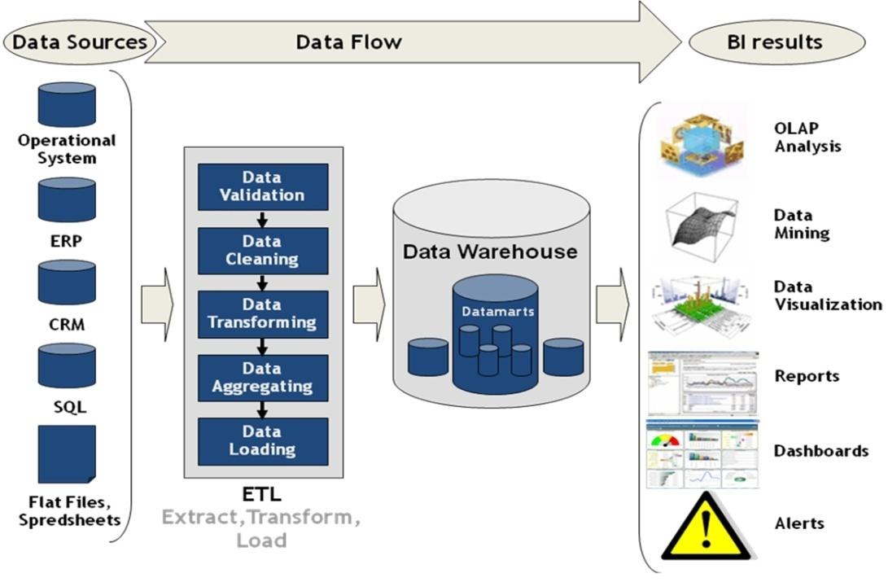

**Fig. 1.** BI Framework: Key Components [5]

The figure above visualised and summarised key components of Business Intelligence Framework

* 1. Characteristic and Evolution

The term Business Intelligence has evolved and refined accordingly throughout the time since 1950s. Likewise with it characters which also evolves with time. The technology evolution as described in the Gartner Hype Cycle consisted of three BI&A Era:

## 2.3.1 BI&A 1.0

BI&A 1.0 is where the BI&A technologies and applications currently adopted by the industry. It is where data well organised, collected or sourced by the organisation through different legacy systems. Normally those data are stored in either commercial or Open Source based RDBMS

The analytical technics usage was very popular in the 1990s. It is an evolution from statistical methods which was developed in the 1970s and data mining which was developed in the 1980s. Apart from that, data management and warehousing are also deemed to be the basis of BI&A 1.0. And for converting and integrating enterprise-specific, data mart design and ETL tool are play significant roles in this area.

Other tools such as OLAP and intuitive based reporting tools are being used to discover important data characteristics. As in the case of analysing and visualising various performance metric, BPM with dashboard and scorecard are being utilised to achieved the objective. Additionally, statistical analysis and data mining technics are also being embraced for association analysis, data segmentation and clustering, classification and regression analysis, anomaly detection, and predictive modelling in various business applications (Sallam et al. 2011).

## 2.3.2 BI&A 2.0

As early as 2000s, the evolution of internet and web starting to offer exceptional data collection and analytical research and development breakthrough. The earlier version of Web 1.0 for such web search engine and e-commerce portal, allow the company to expose their businesses online and communicate directly with their customers. Other than products and business contents, the company would also be able to collect other relevant information such as where the user coming from with IP addresses information, what user search. And this information is collected through technology call cookies and server logs. New collected information is considered a new gold mine for company since they are now able to use the data to understand customers’ needs and identifying new business opportunities. With the advent of Web 2.0, there were new growth of web application such as social media network (SNN) application namely Facebook and Twitter. These two applications are considered user generated content which generate abundance of new contents for example forums, online groups, web blogs, social networking sites, social multimedia sites (for photos and videos), and even virtual worlds and social games (O’Reilly 2005). These has led to new era BI&A 2.0 research where the focus is on text and web mining analytics for unstructured web contents.

Unlike its predecessor, BI&A 2.0 systems will require the integration of mature and scalable technics in text mining (e.g., information extraction, topic identification, opinion mining, question-answering), web mining, social network analysis, and spatial-temporal analysis with existing DBMS-based BI&A 1.0 systems

The impact from this new research has led to new growth in online marketing and advertising based on the analysed collected data. Company like Google, Facebook, Alibaba, Baidu, Tencent and Microsoft has been dominant and controlling the market share for online/digital and mobile advertising. [7]

## 2.3.3 BI&A 3.0

As the BI&A 2.0 is progressively in the research from the industry and academic, it does not stop the new and emerging BI&A 3.0 come into picture. With the surge of mobile devices usage in the recent years so does the need for new strategy and solutions for BI&A 3.0. According to the market research reported by eMarketer in Nov 2016, nearly half (49.7%) of mobile phone users across the globe will use a smartphone at least once a month in 2016. They also predict that that there will be around 4.30 billion mobile phone users worldwide in 2016, representing 58.7% of the global population. And the number of mobile phone users will climb to 4.78 billion in 2020. In the same report, it mentioned that 4G traffic accounted for 69% of all mobile web traffic in 2016 [8]. In another article in The Economist (2011), it is projected that the number of mobile connected devices would reach 10 billion in 2020. Mobile devices and their complete ecosystems, are transforming diverse aspects of society, from education to healthcare and from entertainment to governments. Not to left behind is the booming market of Internet of Things (IoT). Forbes in their article ‘2017 Roundup Of Internet Of Things Forecasts’ projected that by 2020, the installed base of the Internet of Things devices is forecast to grow to almost 31billions worldwide. By 2025 the installed base of IoT devices will be over 75.4billions devices [9]. These number has shown that there is an exciting new stream of innovation coming up.

The characteristics and abilities of such mobile devices and IoT devices to support location-aware analysis, person-centred analysis, and context-relevant analysis and mobile visualisation and human-computer interaction (HCI) transactions will continue to present promising research area throughout the 2010s. Even though the academic research on mobile BI is still in an primary stage, it seems the development and progress is promising to cater for incoming Web 3.0 requirements.

The time of the 2010s guarantees to be an energizing one for high-affect BI&A innovative work for both industry and the scholarly community. The business group and industry have officially found a way to embrace BI&A for their requirements. The IS people group faces one of a kind difficulties and openings in having logical and societal effects that are pertinent and durable (Chen 2011a). IS research and training programs need to painstakingly assess future bearings, educational module, and activity designs, from BI&A 1.0 to 3.0.

Table 3 summarizes the key characteristics of BI&A 1.0, 2.0, and 3.0 in relation to the Gartner BI platforms core capabilities and hype cycle.

**Table 3** BI&A Evolution: Key Characteristics and Capabilities



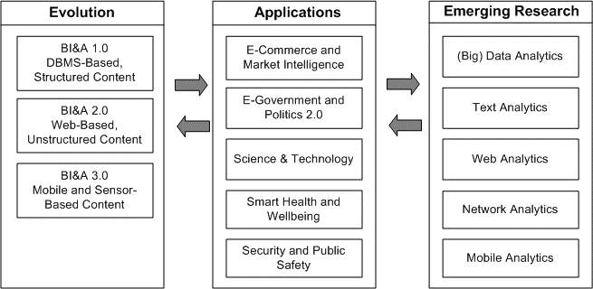

**Fig. 2.** BI&A Overview: Evolution, Applications, and Emerging Research

1. **Decision Support System (DSS) Concept, Characteristic and Benefits**

In the end of the 1960s, computer since have been developing applying a new system to help the management with decision makers. A lot of DSS systems were proposed in 1980s(cf., Alter, 1980; Sprague & Carlson, 1982),but that time the technology was limited and the hardware can’t support the complicated calculations, but technology developments and the new applications led to create and expand DSS framework (cf., Power, 2000a, 2000b, 2001).the expanded one become a mature model in 2002 helps decision makers and DSS engineers to categorize and put in details the basics of potential decision support projects as well as existing DSS.

Many terms are used for specific types of DSS. For example, some vendors and managers use the terms “business intelligence,” “collaborative systems,” “computationally oriented DSS,” “data warehousing,” “model-based DSS,” and “online analytical processing (OLAP)” software to label decision support software.

And as usual after the since finished it task the software sellers start controlling and try to make it more specialized terms for marketing purposes. Some of DSS are subsystems of the original information system not part of it which make the flow of the system in degraded situation because DSS systems add a huge complexity to the systems and if the system is not well designed for this the owners will have big problems with the years. DSS are a broad class of information systems used to assist people in decision-making activities (cf., Power, 2004).

According to Alter (1980), DSS can “take on many different forms and can be used in many different ways” (p. 71). DSS has different targets and capabilities depends on the system what you want to apply to. Some of them focusing on the data or models and some on how to do the communication and collaboration. And DSS also has different scopes some of them focused on one user for the analysis and other DSS are focusing on, any users in organization

1. How Emerging Business Intelligent Tools Compliment Decision Support Process

We all can see how much the technology is evolving and this including the BI and especially for the applications of decision making. There are a lot of fields now they need this kind of applications. From government and e-commerce to health-care industry, there are a massive data generated from all over the internet, mobile devices, sensor based IOT devices (like weather, medical sensors) all of these things together produced data at rate exabyte scale. With all these Big Data what we have it helps us to fine a chance to discover and find new views for the business and from these results we can make a new plan to any industry. These results couples with BI technologies helping to create critical decision making.  
 In 2016, a Forrester Research Report shows the maturity and trajectory of several emerging analytics technology (fig 3). The report shows that AI (Artificial Intelligence) and ML (Machine learning) are increasing the impacting on other technologies

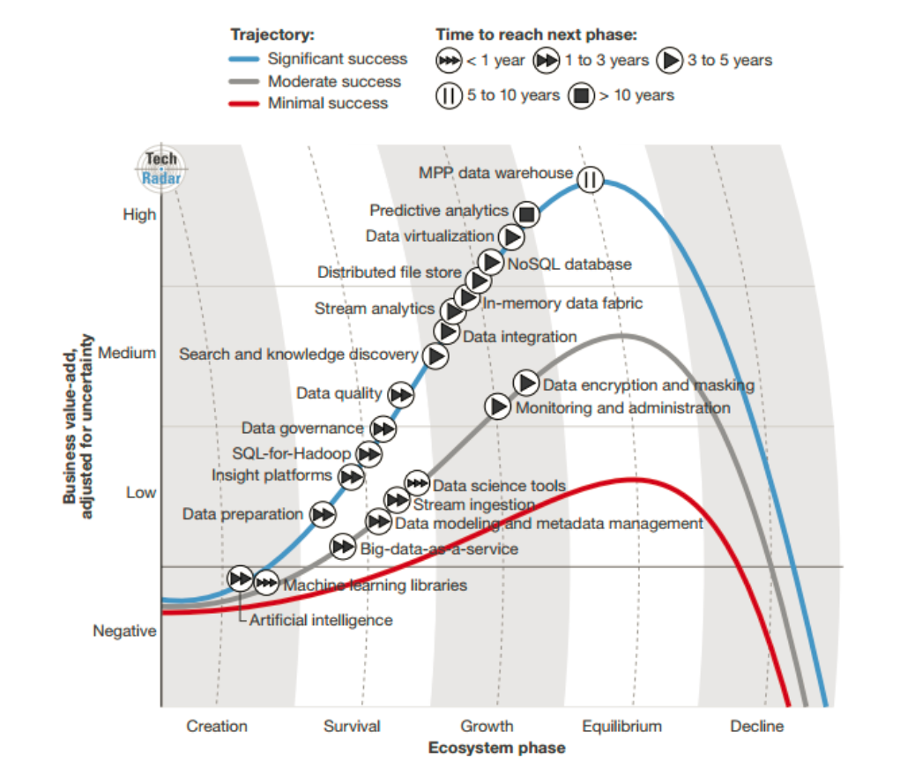  
 Fig.3.Big Data Technology Maturity Cycle [15]

* 1. Big Data Analytics:

Companies these days are starting to collect information in more creatives ways. The enterprise dataset started to expand. Zikopoulus et al. they estimate about 35 zettabytes of data produced by 2010 [18]. These makes problems in managing the rise size data (which is Big Data) to become a very difficult task. This give a lot of chances to find a hidden information’s [19]. Big Data Analytics require new method and software to fast analyse big chunk of data and data types like images, videos and emails to generate action facts base so we can use it later in decision making [21]. Big Data works with both structured and unstructured data and requires data analysis techniques to solve the problem [20]. We can see in the new technologies in Big Dara Analytics are in neural networks and genetic algorithm which both have applications in classification/prediction and always enhancing it. MapReducer are becoming popular techniques to access large scale data in parallel.

4.2. Text Analytics:

Big companies and organizations are having a very big of row text in their data bases coming from multi places like social-network, emails, commercials etc. a very important research already finished Natural Language Processing. Using NLP with the Big Data what we have (row text) follow up in new fields like information extraction, Q/A Analysis, opinion mining, and topic models.

4.3 Mobile Analytics:

Mobile BI is focusing on spreading the BI market in very large way (Bitterer 2011) [17].  
In a 2012 report, eMarket predict that market for mobile ads will increase to 10.8$ billion in 2016 from 2.6$ billion in 2012 (Snider 2012) [16]. The capacity to get large of personalized, contextual, location-specific content using mobile phones it is quite easy and facilitated a new way of marketing and new technologies like BI&A to get in. New analytics areas are rising, e.g., portable detecting applications to track clients; portable web-based social networking; versatile detailing and perception; portable social development for m-wellbeing and m-learning; and personalization and behavioural demonstrating for **v**ersatile applications. As portable examination enables advertisers to associate with singular clients, it can demonstrate instrumental in the fate of item plan and promote.

4.4 Advanced Machine Learning for DSS:

AI and Advanced machine learning was ranked number 1 amongst to 10 strategic technologies trends in 2017 according to Gartner’s Report [22]. It also has another technology like neural networks, deep learning and NLP, and also have focusing on self-learning as well. We can see AI machine learning in banking systems used to detect any fraudulent activities. Advanced neural networks are taking the cloud optimization and implementation to a new era. Forrester reported in their TechRadar Big Data article [39], we expected for the Artificial Intelligence to have a very big improvement in the next years because the machine learning is increasing and getting better. Nowadays companies looking to create digital innovation to have machine learning in decision making process to make the business better.

4.5. Predictive and Prescriptive Analytics:

During the time of BI&A 1.0, most organizations concentrated on descriptive and indicative Business Intelligence. However not very many received some type of predictive analytics, they were generally based on measurable models. Predictive analytics is an act of estimating future result in view of existing and authentic informational indexes. It's an augmentation of information mining. Prescient investigation assesses what can occur in future with a quantifiable precision. Value streamlining can be an expanded utilize case for Predictive analytics, where an administrator may foresee the effects of changing costs on an item and gauge its effect for an ideal cost. By foreseeing request, carriers can choose which courses to open, or in which courses they can increment or on the other hand, diminish recurrence. Inns can anticipate every day expected visitor check, and upgrade the cost or take advertising choices.

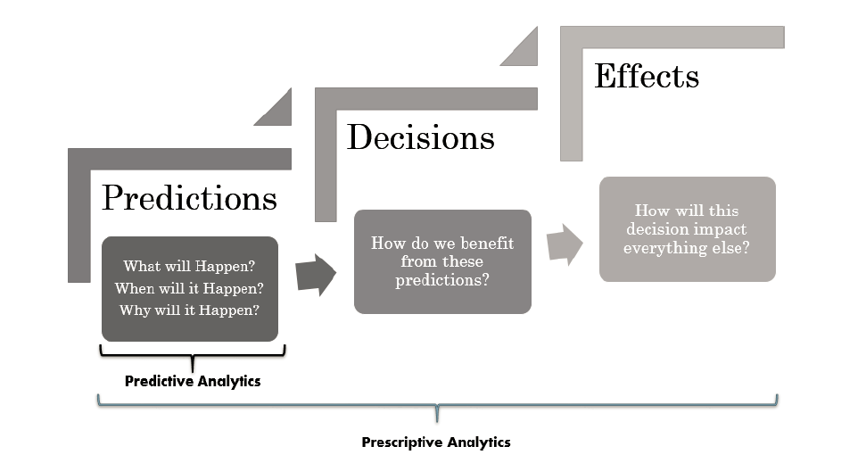

FIG.4 Predictive and Prescriptive Analytics

The Predictive Methods that picked up prominence lately are: Artificial Neural Networks (ANN) furthermore, Autoregressive Integrated Moving Average (ARIMA). The neural network is utilized to catch affiliations and distinguish patterns. ARIMA is using for predicting the future and the results. Prescriptive algorithms utilize a vast assortment of procedures, for example, machine learning, artificial intelligence, furthermore, statistical sciences, to propose a perfect choice by dissecting conceivable situations for different conceivable activities. Google's Self-Driving auto utilizes Prescriptive Investigation to suspect the results of every choice. The auto needs to suspect what it may experience as far as vehicles, people on foot and so forth and the effect of a conceivable move before making a genuine choice.

4.6. Collaborative BI:

The collaborative BI is a reconciliation of joint effort tools, including person to person communication and business intelligence tools. Self-service BI is a developing pattern that improves collaborative BI. It concentrates on sharing of investigation, reports and dashboards among the associates, associated with their information-driven cautions and membership. The pattern is to move towards the democratization of information were as opposed to working in the storehouse, individuals will expand on each other's work, and enable the business by utilizing the innovativeness and scholarly drive of the whole association.

4.7. Embedded BI:

As business intelligence and information getting democratized, ideas like Embedded BI is rising. Embedded BI is simply the aftereffect of the combination benefit BI tools with ordinarily utilized business applications. A mainstream case is smart to call focus applications, wherein a view of the grumblings, the call focusses the rep can utilize BI in a hurry to discover the arrangements and strategically pitch to the client some related item by breaking down client conduct. At a further developed level, installed BI can live inside a robotized work process, where certain activities are consequently activated in light of the parameters by chiefs. Human services are a case of that. On the off chance that in a healing facility, the sanitization office has a gear glitch, this could defer many surgeries. On the off chance that leaders set certain parameters to instantly raise cautions for high-chance occasions, this can diminish the turnaround time extensively.

4.8. Cloud Platform:

Because of fast increasing in count of people who using the internet the volume of the data is getting bigger, and the cloud solutions are getting more reasonable and cheaper. The companies are moving to use cloud platform. Cloud platforms are fully scalable and easy to optimize to fit your budget. And even not only the tools now cloud computing provide very convenient DB hosting and manging that’s make it easy to manage and extract the data.

1. Conclusion:

In the end, we can say that we have discussed the evolution of Decision Support System (DSS) and show some reports on the emerging trends of Business Inelegance for DSS.  
before people who do the marketing campaign was using the financial data or market perceptions to do their own strategy but now with this new technology they can listen to their own customer and know exactly how to market their own products. We can see how big companies now rely on how they integrate these in their decision-making process.

1. References

[1] ‘A timeline of Business Intelligence: How decision-makers have been making sense of data’, https://www.cio.co.uk/it-applications/business-intelligence-timeline-3429740/, accessed October 31, 2016

[2] ‘History of Business Intelligence’, https://www.betterbuys.com/bi/history-of-business-intelligence/, accessed 26 September 2014

[3] ‘A Visual History of Business Intelligence’, https://www.slideshare.net/InformationBuilders/history-of-bi, accessed 17 July 2012

[4] ‘Business performance management’,https://en.wikipedia.org/wiki/Business_performance_management, accessed 29 Dec 2017

[5] ‘What is a 'Time Series'’ https://www.investopedia.com/terms/t/timeseries.asp, accessed 29 Dec 2017

[6] ‘Implementation of OLAP Solution’ http://olap.com/olap-definition/, accessed 29 Dec 2017

[7] ‘Google leads the world in digital and mobile ad revenue’, https://www.recode.net/2017/7/24/16020330/google-digital-mobile-ad-revenue-world-leader-facebook-growth, accessed 24 July 2017

[8] ‘Mobile Phone, Smartphone Usage Varies Globally’, https://www.emarketer.com/Article/Mobile-Phone-Smartphone-Usage-Varies-Globally/1014738, accessed 23 Nov 2016

[9] ‘2017 Roundup Of Internet Of Things Forecasts’, ttps://www.forbes.com/sites/louiscolumbus/2017/12/10/2017-roundup-of-internet-of-things-forecasts, accessed 10 Dec 2017

[10] Chen, Hsinchun; Chiang, Roger H. L.; and Storey, Veda C.. 2012. "Business Intelligence and Analytics: From Big Data to Big Impact," MIS Quarterly, (36: 4) pp.1165-1188.

[11] Evelin Vatovec Krmac: ' Intelligent Value Chain Networks: Business Intelligence and Other ICT Tools and Technologies in Supply/Demand Chains ', in Sanda Renko: Supply Chain Management - New Perspectives' (InTech, 2011, Edited edn.)

[12] IET., 'Report Title' (Publisher, 2013), pp. 1-5

[13] Abbott, N.L.: 'The title of the thesis'. PhD thesis, XYZ University, 2005

[14] BS1234: 'The title of the standard', 2006

[15] Yuhanna N and Hopkins B. (2016). TechRadar™: Big Data, Q1 2016. Big Data Is Critical Technology For

Insights-Driven Businesses. Forrester

[16] Snider M. (2012). “More Businesses Getting Their Game On,” USA Today, July 30.

[17] Bitterer A. (2011). “Hype Cycle for Business Intelligence,” Gartner, Inc., Stamford, CT.

[18] Zikopoulus P C, Eaton C, deRoos D, Deutsch T, Lapis G. (2012). Understanding Big Data: Analytics for

Enterprise Class Hadoop and Streaming Data. McGrow Hill, New York

[19] Renu R S, Mocko G, Koneru A. (2013). Use of big data and knowledge discovery to create data backbones for

decision support systems. Procedia Comput. Sci. 20, 446–453

[20] Chen M, Mao S, Liu Y. (2014). Big data: a survey. Mob. Netw. Appl. 19, 171–209

[21] Berman J J. (2013). Principles of Big Data Preparing, Sharing, and Analyzing Complex Information. Elsevier, Waltham

[22] Panetta K (2016). Gartner’s Top 10 Strategic Technology Trends for 2017.

(http://www.gartner.com/smarterwithgartner/gartners-top-10-technology-trends-2017)